2023 CS504 Project

MEGHANA KATTA

George Mason University

November 14,2023

3. Requirements

3.1. Database Design

1. Define the scope of the project and identify the entities and their relationships.

ANS: The design and implementation of a database management system to assist library staff in managing their resources, such as books, magazines, digital media, and other materials, is included in the scope of the Library Management System project. The technology will also make it easier to track and borrow library resources and give members of the public efficient access to their personal information. For both library personnel and patrons, the library management system seeks to eliminate redundancy and guarantee data integrity.

1.Material

Represents individual items available in the library, such as books, magazines, e-books,

and audiobooks.

Attributes: ● Material_ID: A unique identifier for each material.

● Title: The title of the material.

● Publication_Date: The date of publication of the material.

● Catalog_ID: A reference to the catalog entry for the material.

● Genre_ID: A reference to the genre of the material.

2. Catalog

Represents a record of library materials with information on their availability and location.

Attributes:

● Catalog_ID: A unique identifier for each catalog entry.

● Name: The name of the catalog.

● Location: The location of the material within the library.

3. Genre

Represents the various genres or categories of library materials.

Attributes:

● Genre_ID: A unique identifier for each genre.

● Name: The name of the genre.

● Description: The brief introduction of the genre.

4. Borrow

Represents the borrowing activity of library materials by members.

Attributes:

● Borrow_ID: A unique identifier for each borrowing transaction.

● Material_ID: A reference to the borrowed material.

● Member_ID: A reference to the member who borrowed the material.

● Staff_ID: A reference to the staff who processed the transaction.

● Borrow_Date: The date the material was borrowed.

● Due_Date: The date the material is due.

● Return_Date: The date the material is returned.

5. Author

Represents authors who have created library materials.

Attributes: ● Author_ID: A unique identifier for each author.

● Name: The name of the author.

● Birth_Date: The birth date of the author.

● Nationality: The nationality of the author

6.Authorship

Represents the relationship between authors and the materials they have created.

Attributes: ● Authorship_ID: A unique identifier for each authorship record.

● Author_ID: A reference to the author.

● Material_ID: A reference to the material authored.

7. Member

Represents library members who can borrow and reserve materials.

Attributes:

● Member_ID: A unique identifier for each member.

● Name: The name of the member.

● Contact_Info: Email address (or phone number) of the member.

● Join_Date: The date the member joined the library.

8. Staff

Represents library staff who manage library resources and assist members.

Attributes:

● Staff_ID: A unique identifier for each staff member.

● Name: The name of the staff member.

● Contact_Info: Email address (or phone number) of the member.

● Job_Title: The job title of the staff member (e.g., librarian, assistant librarian).

● Hire_Date: The date the staff member was hired by the library.

Material has a many-to-one relationship with Catalog.

Material has a many-to-one relationship with Genre.

Material has a many-to-many relationship with Author through Authorship.

Borrow has a many-to-one relationship with Material.

Borrow has a many-to-one relationship with Member.

Borrow has a many-to-one relationship with Staff.

1. Create an Entity-Relationship (ER) diagram to represent the database schema.

ANS:

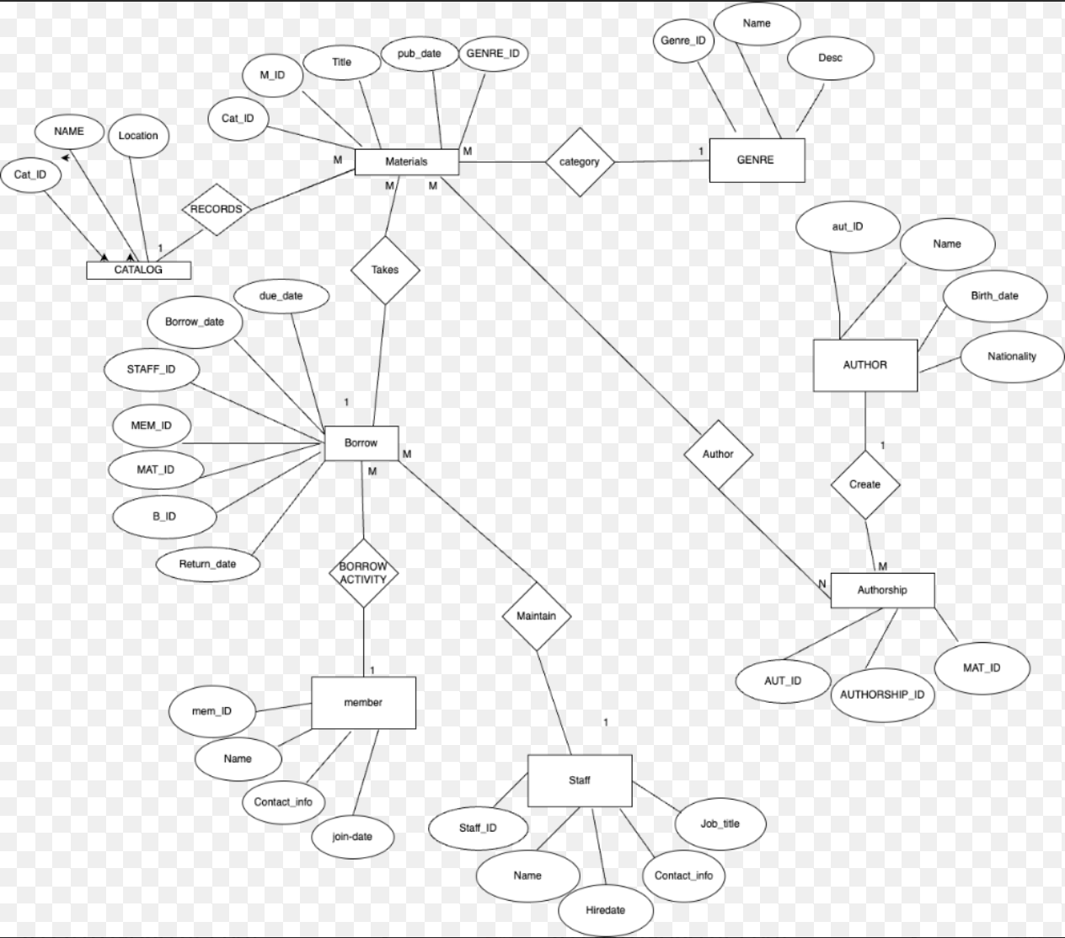

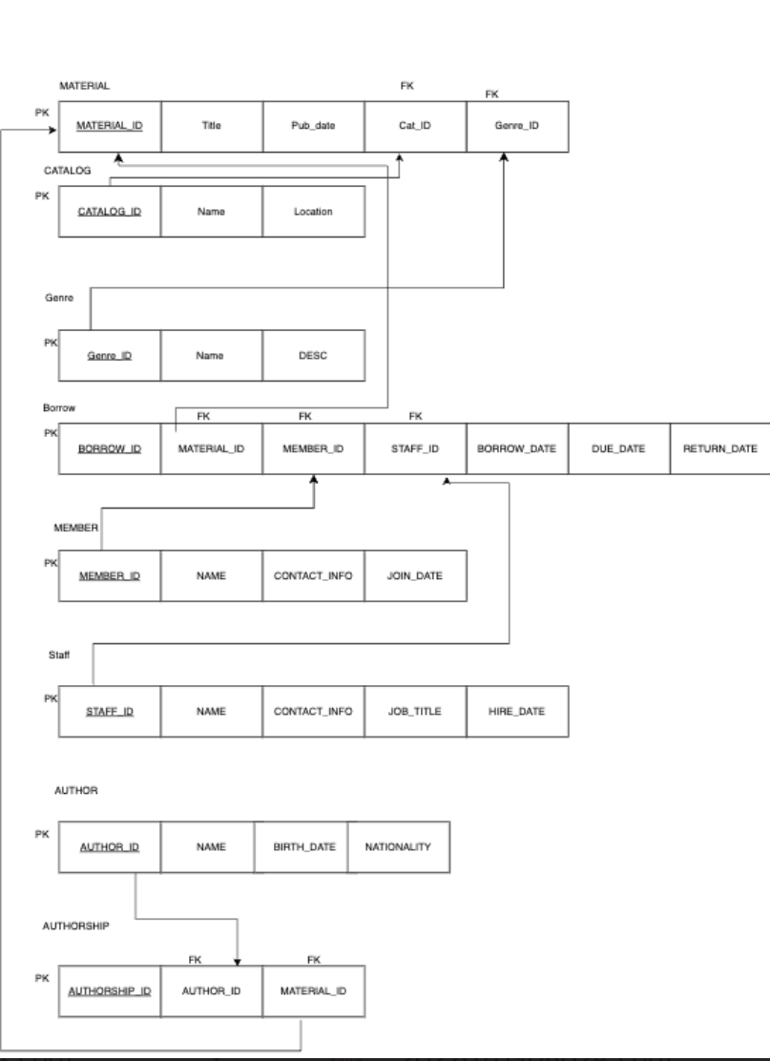

3.2. Database Implementation:

Implement the database schema using SQL or the chosen DBMS's data definition

language (DDL).

CREATE DATABASE Library;

USE Library;

CREATE TABLE MATERIAL (

Material_ID INT PRIMARY KEY,

Title VARCHAR(255) NOT NULL,

Publication_Date Date,

Cataog_ID INT,

Genre_ID INT,

FOREIGN KEY(Catlog_ID) REFERENCES CATALOG(Catlog_ID),

FOREIGN KEY(Genre_ID) REFERENCES GENRE(Genre_ID));

CREATE TABLE CATALOG (

Catlog_ID INT PRIMARY KEY,

Name VARCHAR(255) NOT NULL,

Location VARCHAR(255) NOT NULL);

CREATE TABLE BORROW (

Borrow_ID INT PRIMARY KEY,

Member_ID INT,

Material_ID INT,

Staff_ID INT,

Borrow_Date Date,

Due_Date Date,

Return_Date Date NULL,

FOREIGN KEY(Member_ID) REFERENCES MEMBER(Member_ID),

FOREIGN KEY(Material_ID) REFERENCES MATERIAL(Material_ID),

FOREIGN KEY(Staff_ID) REFERENCES STAFF(Staff_ID)

);

CREATE TABLE GENRE (

Genre_ID INT PRIMARY KEY,

Name VARCHAR (255) NOT NULL,

Description VARCHAR(255) NOT NULL);

CREATE TABLE AUTHOR (

Author_ID INT PRIMARY KEY,

Name VARCHAR(255) NOT NULL,

Birth_Date Date,

Nationality VARCHAR(255));

CREATE TABLE AUTHORSHIP (

Authorship_ID INT PRIMARY KEY,

Author_ID INT,

Material_ID INT,

FOREIGN KEY(Author_ID) REFERENCES AUTHOR(Author_ID),

FOREIGN KEY(Material_ID) REFERENCES MATERIAL(Material_ID));

CREATE TABLE MEMBER (

Member_ID INT PRIMARY KEY,

Name VARCHAR(255) NOT NULL,

Join_Date Date,

Contact_Info VARCHAR(255) NOT NULL

);

CREATE TABLE STAFF (

Staff_ID INT PRIMARY KEY,

Name VARCHAR(255) NOT NULL,

Hire_Date Date,

Contact_Info VARCHAR(255) NOT NULL,

Job_Title VARCHAR(255) NOT NULL

);

* Populate the database with sample data.

INSERT INTO BORROW(Borrow_ID, Member_ID,Material_ID,Staff_ID,Borrow_Date,Due_Date,Return_Date)

VALUES

(20,20,7,2,'2021-10-21','2021-11-11',NULL),

(21,21,1,3,'2021-11-29','2021-12-20',NULL),

(31,1,9,4,'2022-12-28','2023-01-18',NULL),

(32,2,1,4,'2023-01-23','2023-02-13',NULL),

(34,4,11,4,'2023-03-01','2023-03-22',NULL),

(35,5,12,4,'2023-03-10','2023-03-31',NULL),

(36,6,13,4,'2023-03-15','2023-04-05',NULL),

(37,7,17,4,'2023-03-25','2023-04-15',NULL),

(38,8,8,4,'2023-03-30','2023-04-20',NULL),

(39,9,9,4,'2023-03-26','2023-04-16',NULL),

(40,10,20,4,'2023-03-28','2023-04-18',NULL)

;

3.3. Querying and Manipulation

Example queries are included in the Tests section below.

1. Develop a set of SQL queries or stored procedures to perform common tasks, such as

searching, updating, inserting, and deleting records.

Search for borrowed materials by a specific member:

SELECT Material.Title, Borrow.Borrow_Date, Borrow.Due_Date, Borrow.Return_Date

FROM Borrow

INNER JOIN Material ON Borrow.Material_ID = Material.Material_ID

WHERE Borrow.Member_ID = ‘3’;

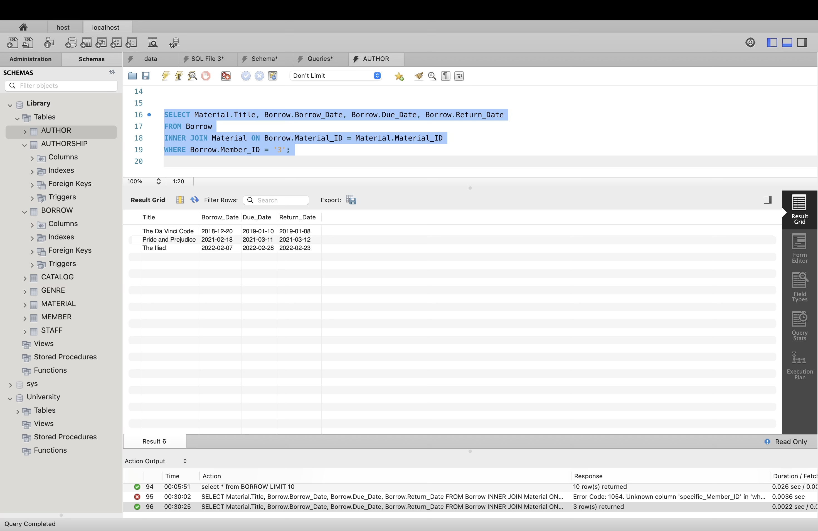

Update material information:

UPDATE Material SET Title = ' A Tale of Two Cities' WHERE Material_ID = ‘3’;

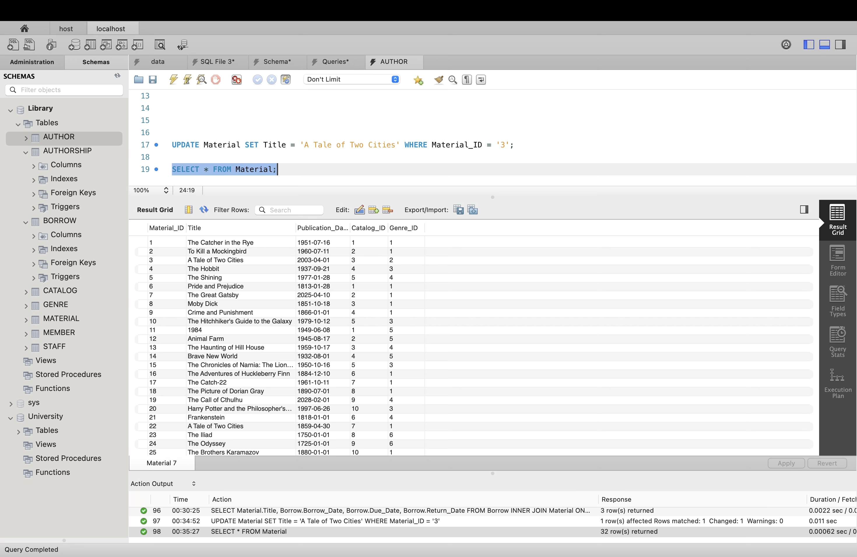

Delete a material and associated authorship records:

DELETE FROM Authorship WHERE Material_ID = ‘3’;

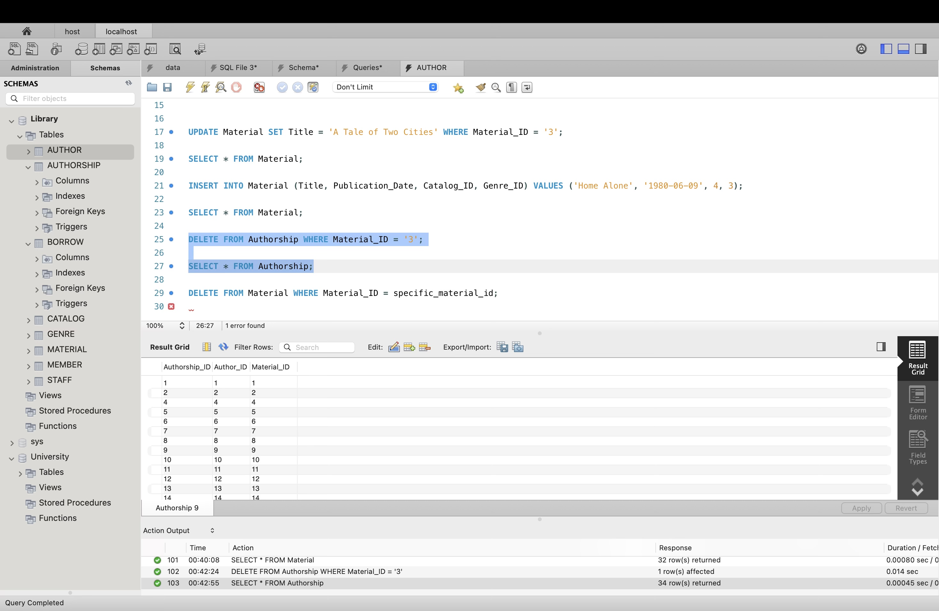

2. Demonstrate the use of advanced querying techniques, such as joins, aggregation, and

subqueries.

Joins:

Retrieve information about borrowed materials, including member names and staff names:

SELECT Borrow.Borrow_ID, Material.Title, Member.Name AS Member_Name, Staff.Name AS Staff_Name

FROM Borrow

JOIN Material ON Borrow.Material_ID = Material.Material_ID

JOIN Member ON Borrow.Member_ID = Member.Member_ID

JOIN Staff ON Borrow.Staff_ID = Staff.Staff_ID;

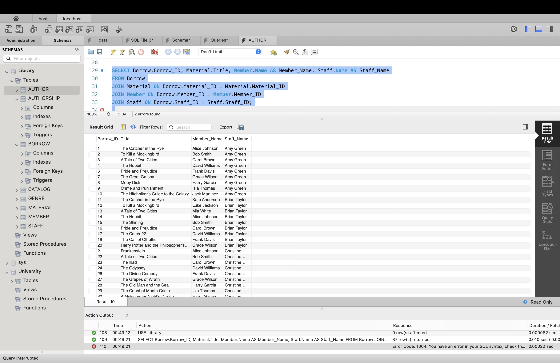

Aggregation:

Count the number of materials in each genre:

SELECT AVG(DATEDIFF(Borrow.Return_Date, Borrow.Borrow_Date)) AS Avg_Borrow_Days

FROM Borrow

WHERE Borrow.Return_Date IS NOT NULL;

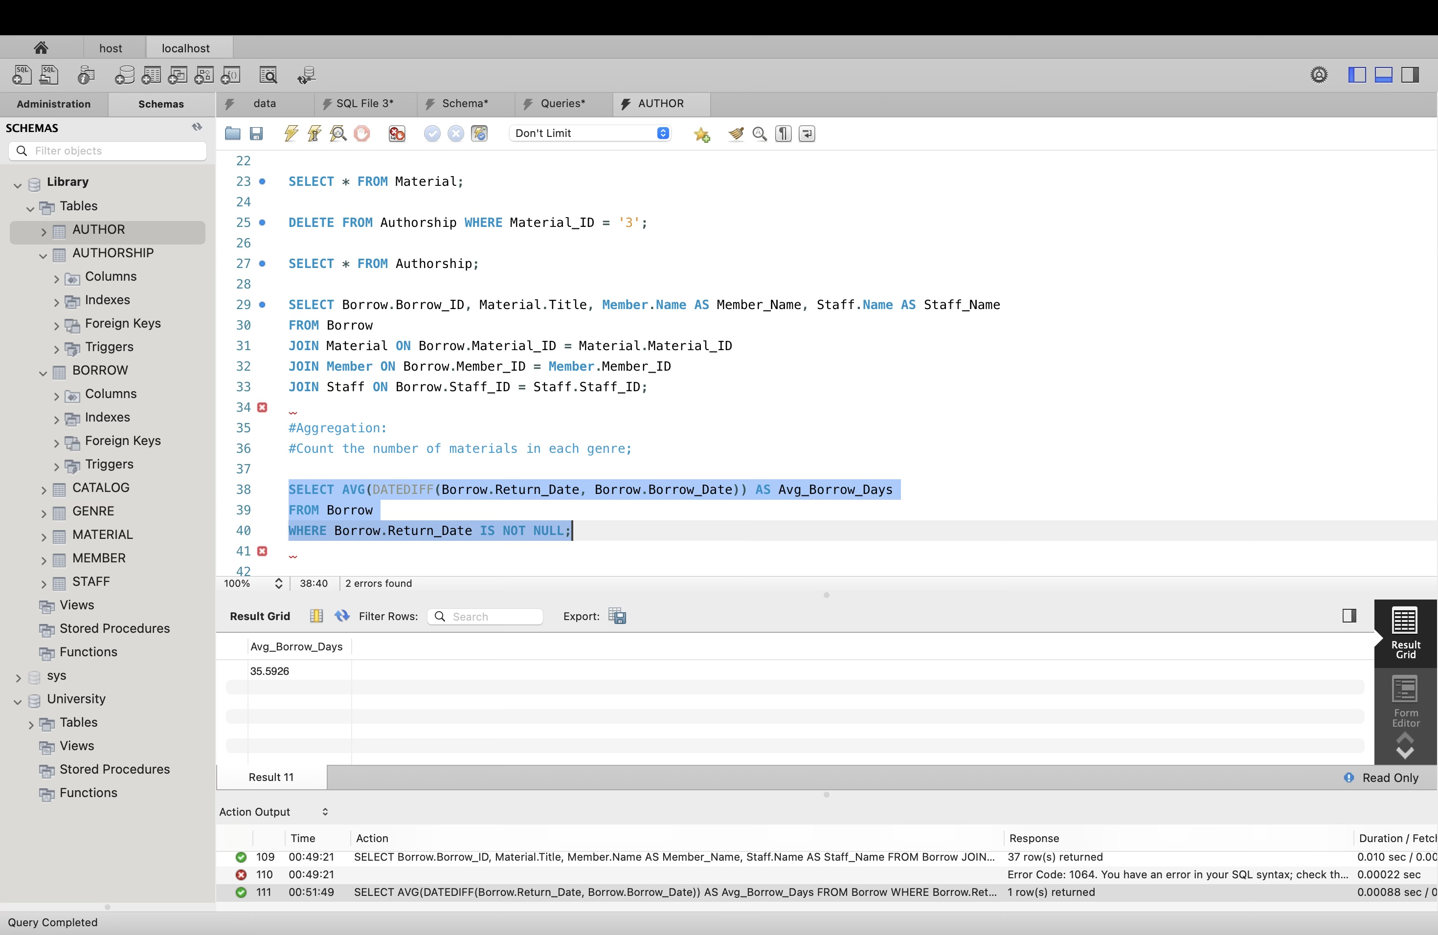

Subqueries:

Find materials with the most extended due date:

SELECT Material.Title, Borrow.Due_Date

FROM Material

JOIN Borrow ON Material.Material_ID = Borrow.Material_ID

WHERE Borrow.Due_Date = (SELECT MAX(Due_Date) FROM Borrow);

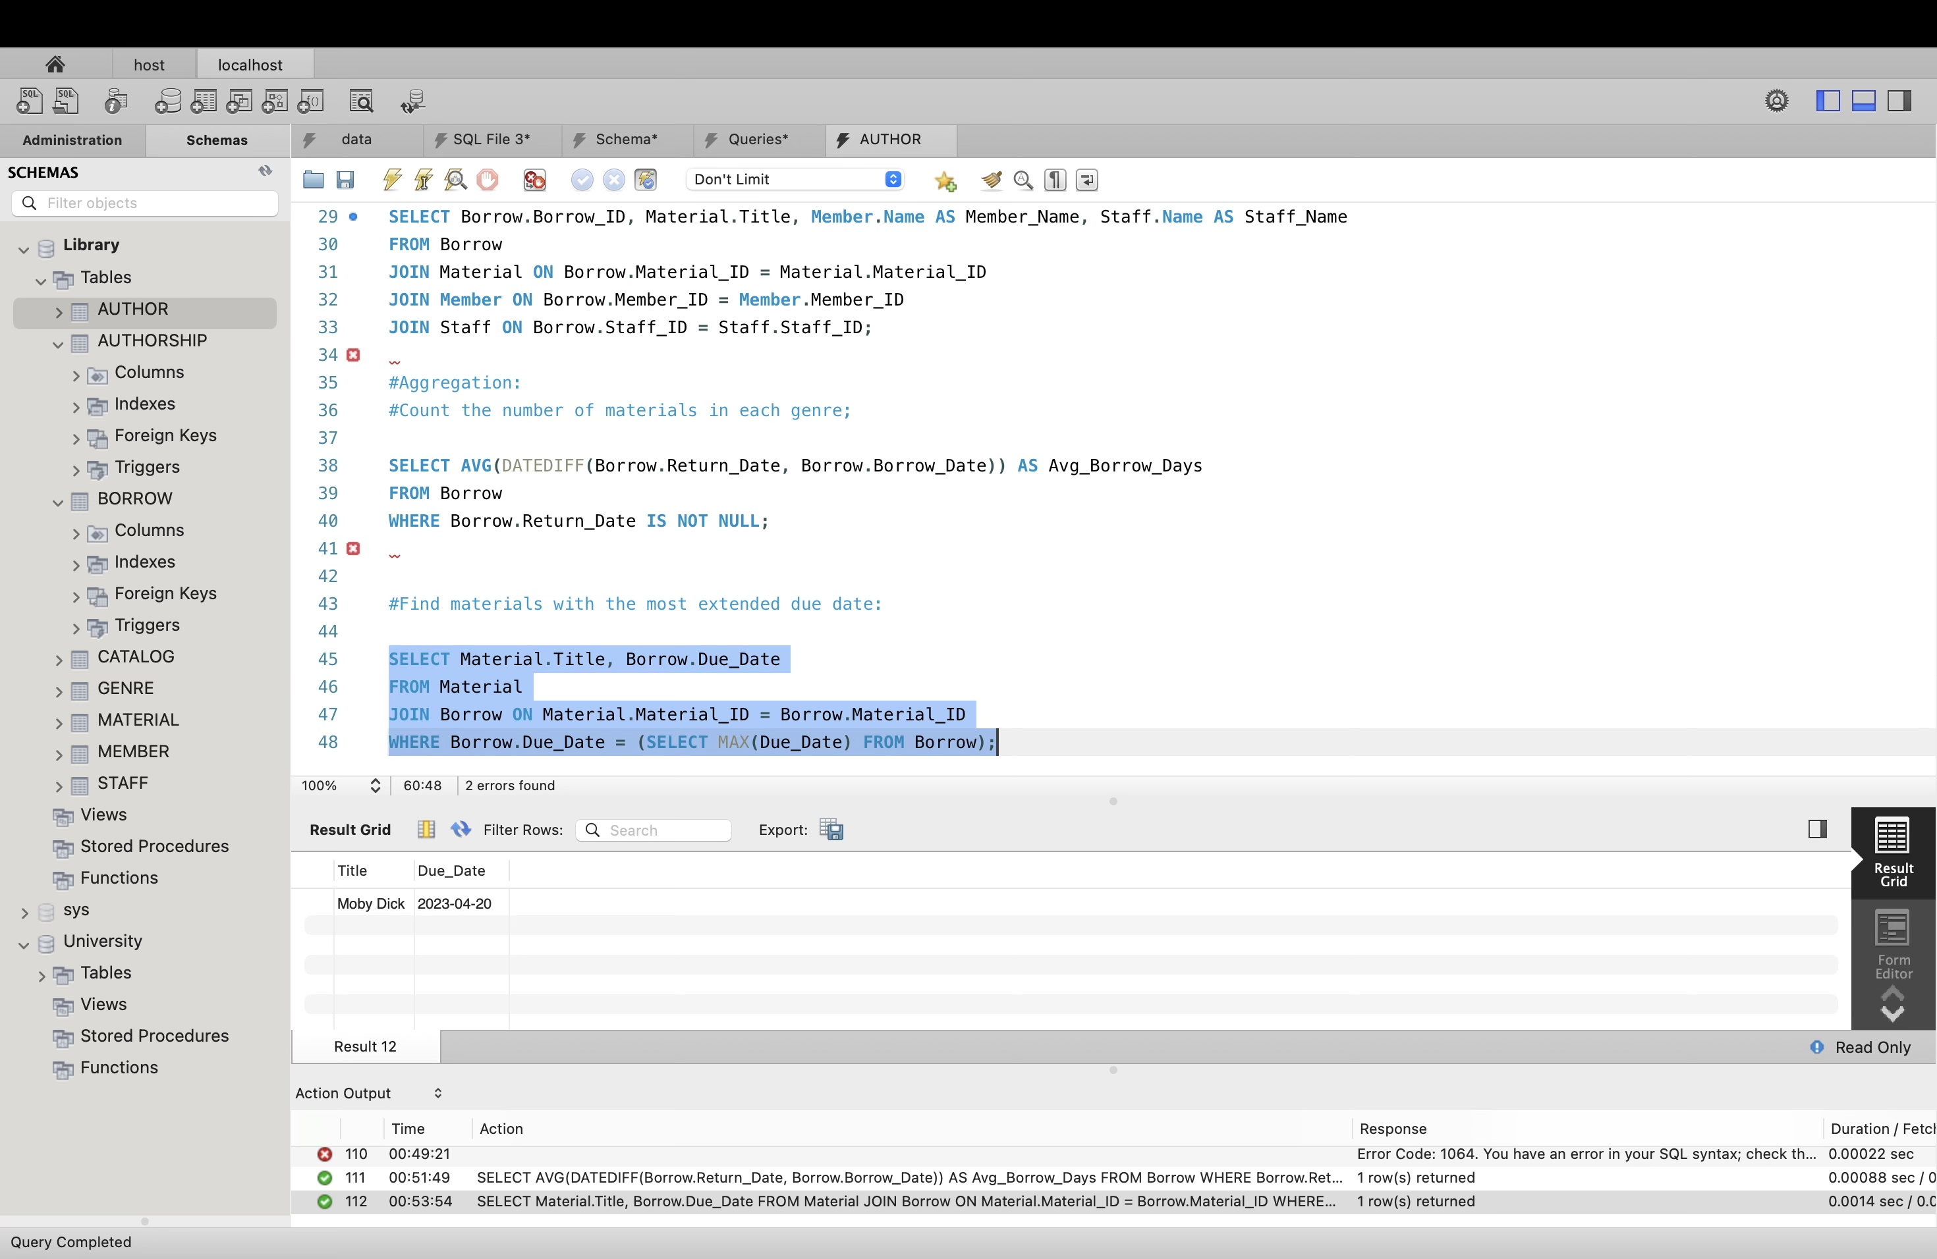

4.1. Queries/Updates:

1. Which materials are currently available in the library? If a material is borrowed and not

returned, it’s not considered as available.

ANS:

select distinct(Title) from Material as Mat

inner join borrow as BW on Mat.Material_ID = BW.Material_ID where BW.Return_Date is not null;

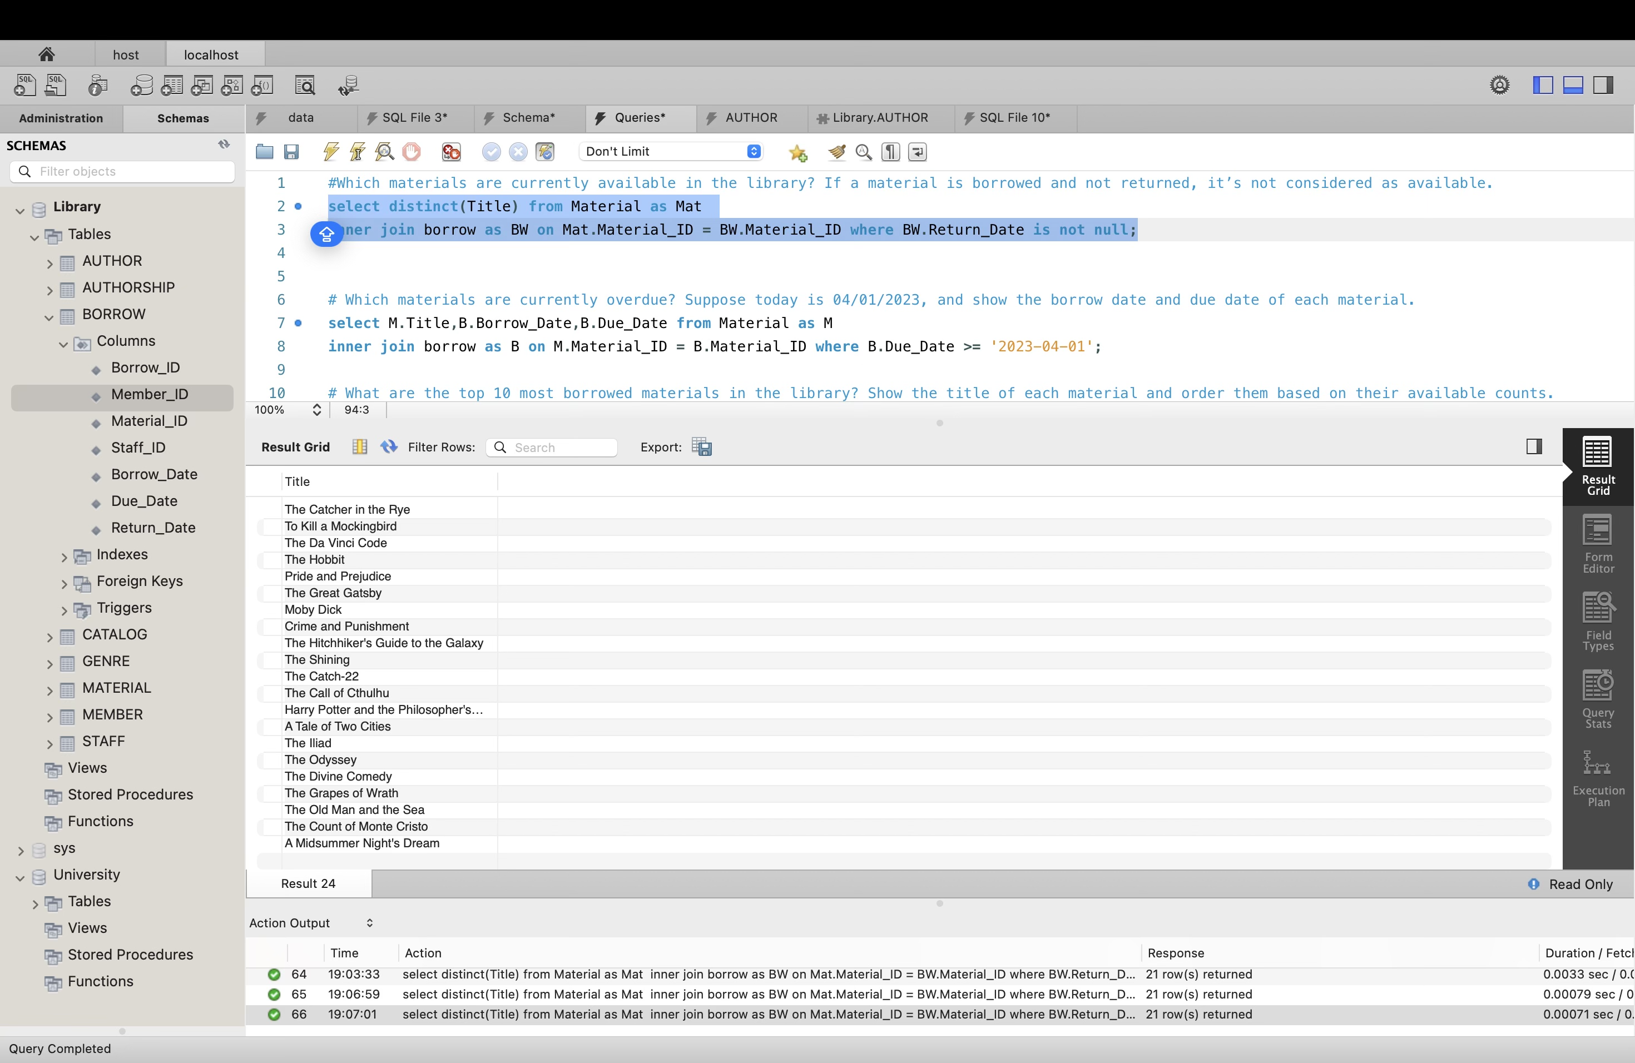

2. Which materials are currently overdue? Suppose today is 04/01/2023, and show the

borrow date and due date of each material.

select Mat.Title,BW.Borrow_Date,BW.Due_Date from Material as Mat

inner join borrow as BW on Mat.Material_ID = BW.Material_ID where BW.Due_Date >= '2023-04-01';

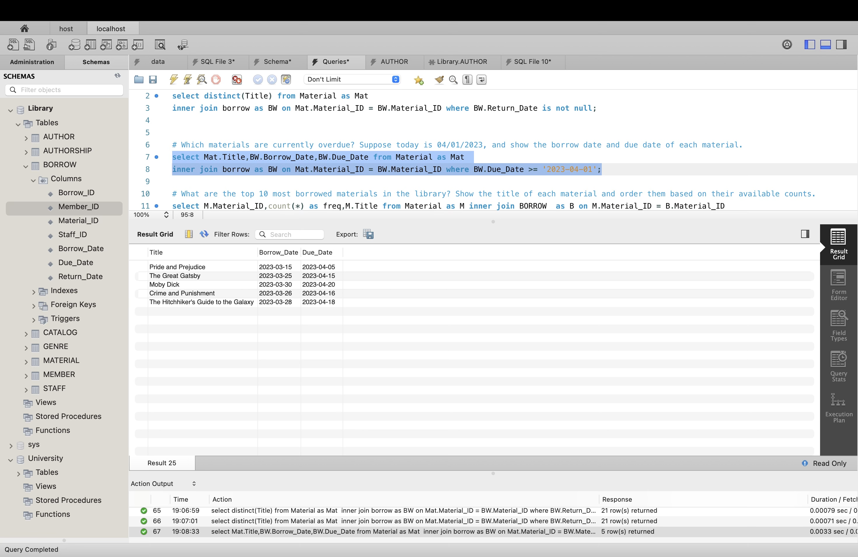

3. What are the top 10 most borrowed materials in the library? Show the title of each

material and order them based on their available counts.

select Mat.Material_ID,count(*) as freq,Mat.Title from Material as Mat inner join BORROW as BW on Mat.Material_ID = BW.Material_ID

group by BW.Material_ID order by freq DESC limit 10;

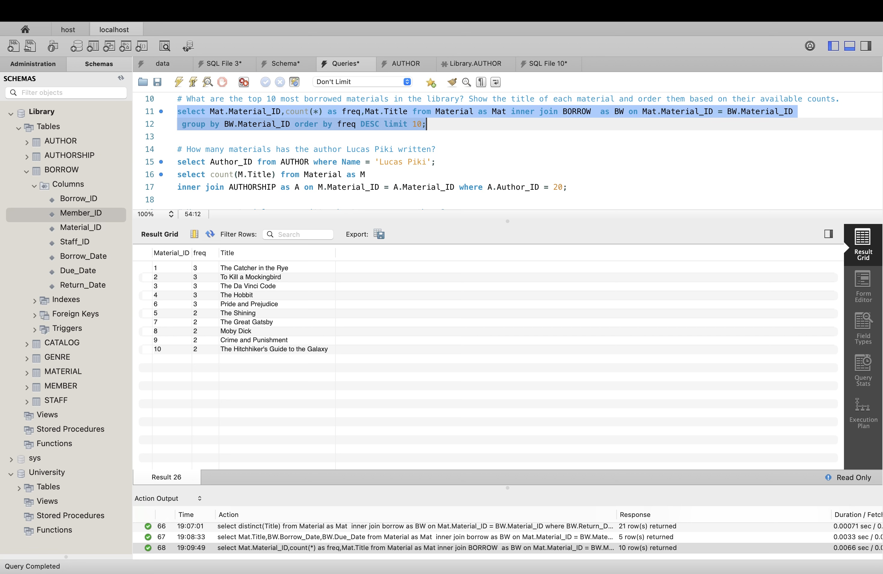

4.How many materials has the author Lucas Piki written?

select Author_ID from AUTHOR where Name = 'Lucas Piki';

select count(Mat.Title) from Material as Mat

inner join AUTHORSHIP as AUS on Mat.Material_ID = AUS.Material_ID where AUS.Author_ID = 20;

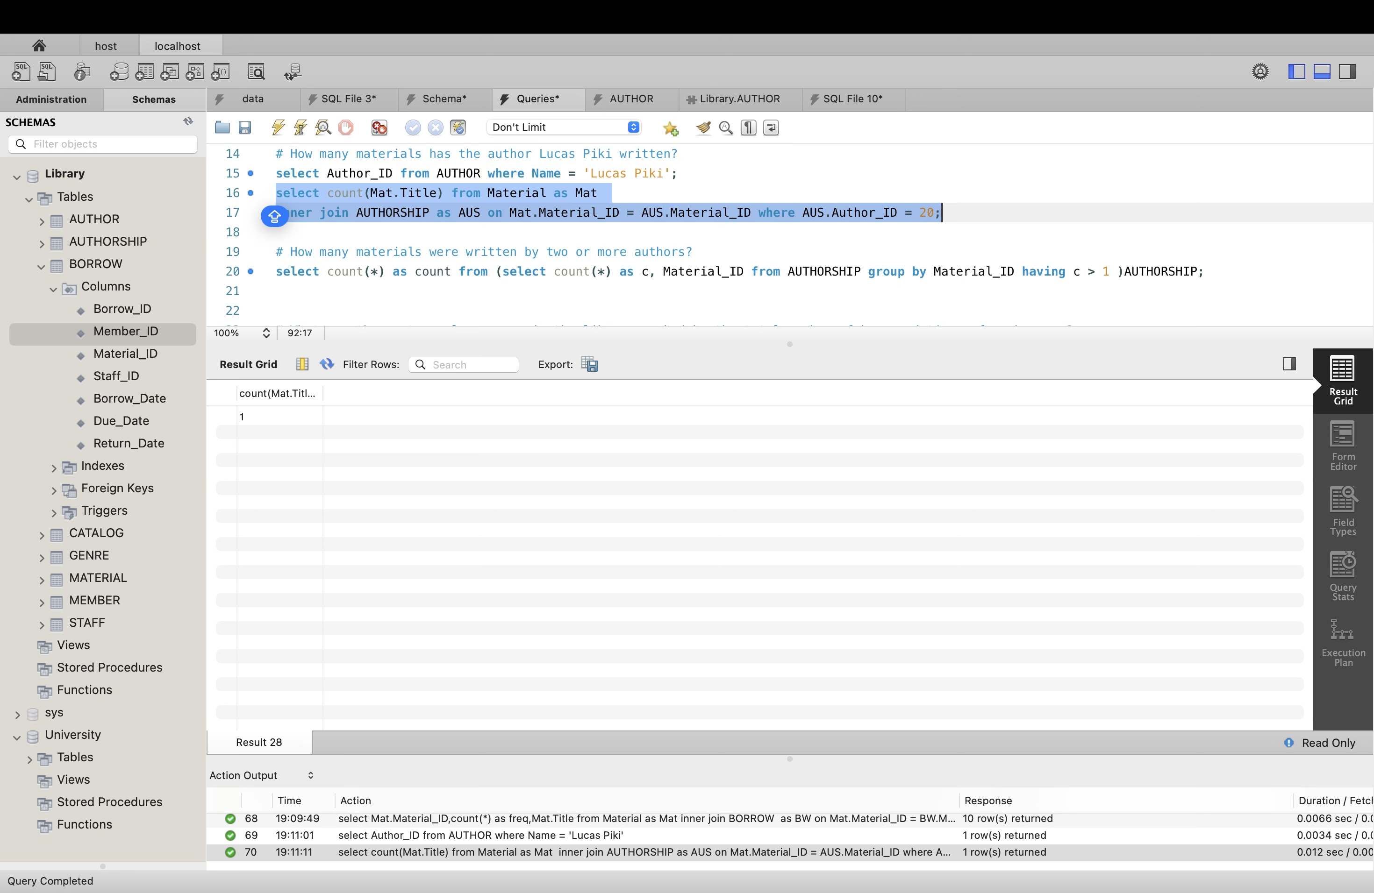

5.How many materials were written by two or more authors?

select count(*) as count from (select count(*) as ct, Material_ID from AUTHORSHIP group by Material_ID having ct > 1 )AUTHORSHIP;

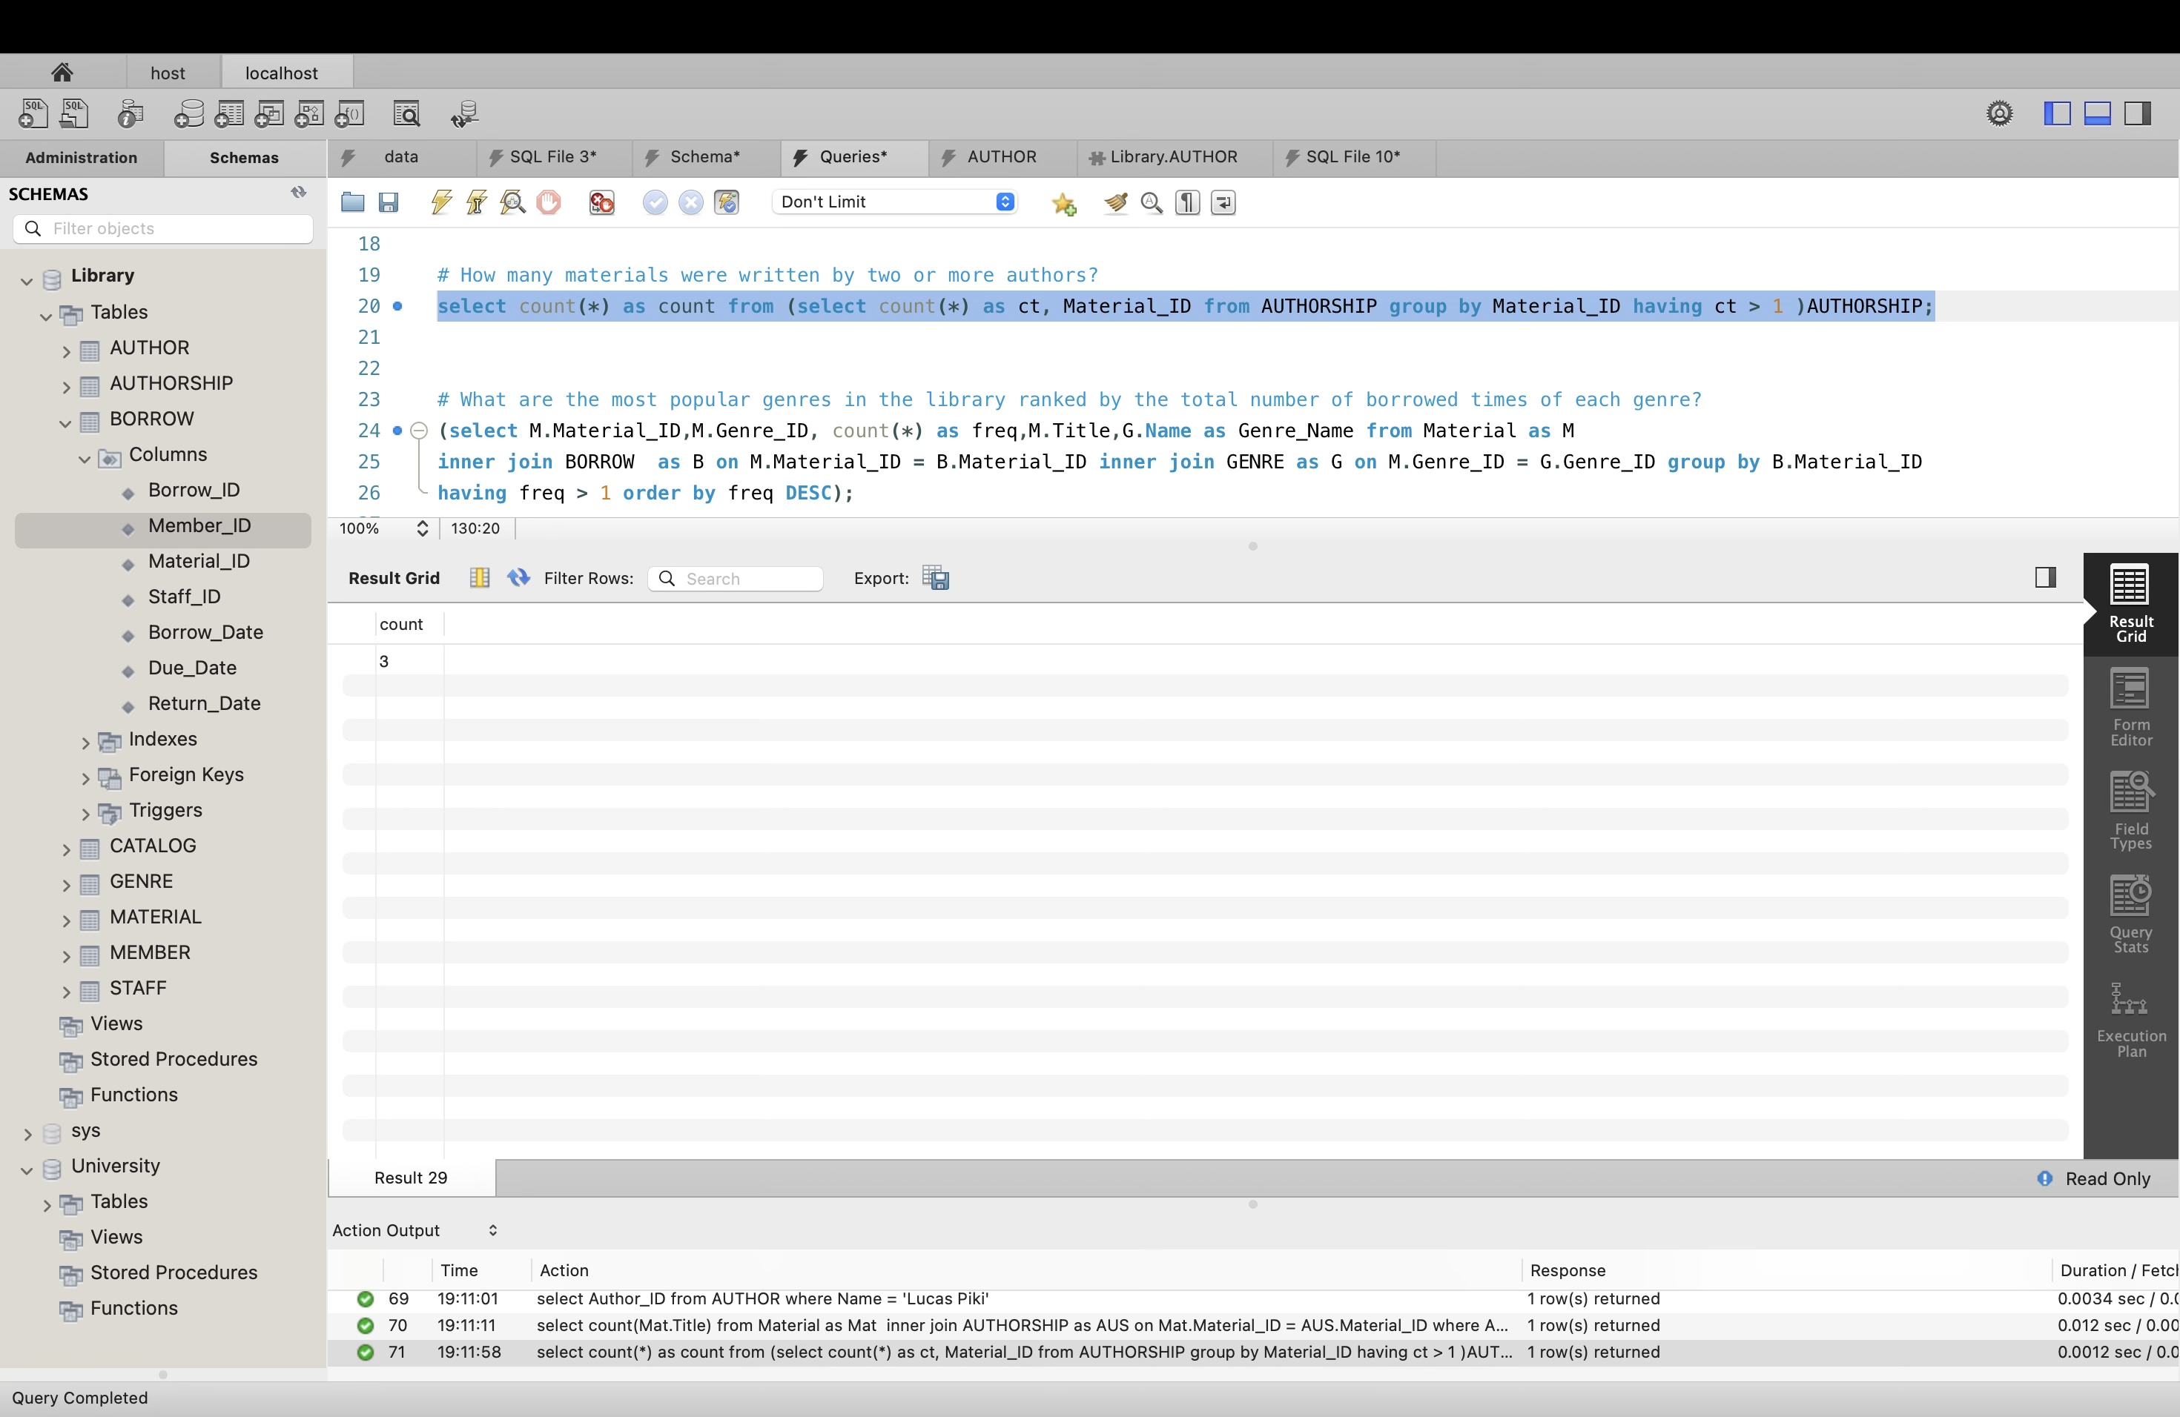

6.What are the most popular genres in the library ranked by the total number of borrowed

times of each genre?

(select Mat.Material_ID,Mat.Genre_ID, count(*) as freq,Mat.Title,Ge.Name as Genre_Name from Material as Mat

inner join BORROW as BW on Mat.Material_ID = BW.Material_ID inner join GENRE as Ge on Mat.Genre_ID = Ge.Genre_ID group by BW.Material_ID

having freq > 1 order by freq DESC);

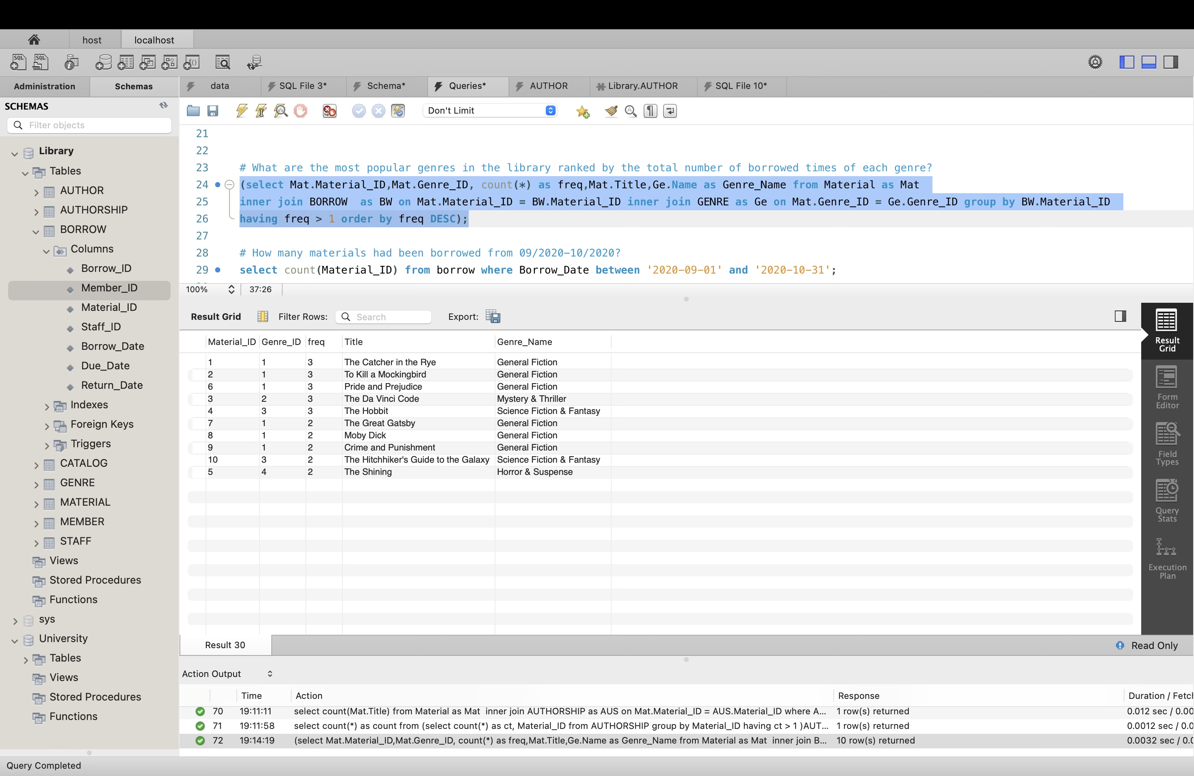

7.How many materials had been borrowed from 09/2020-10/2020?

SELECT COUNT(DISTINCT Mat_ID)

FROM Borrow

WHERE Borrow.Borrow_Date BETWEEN '2020-09-01' AND '2020-10-31';

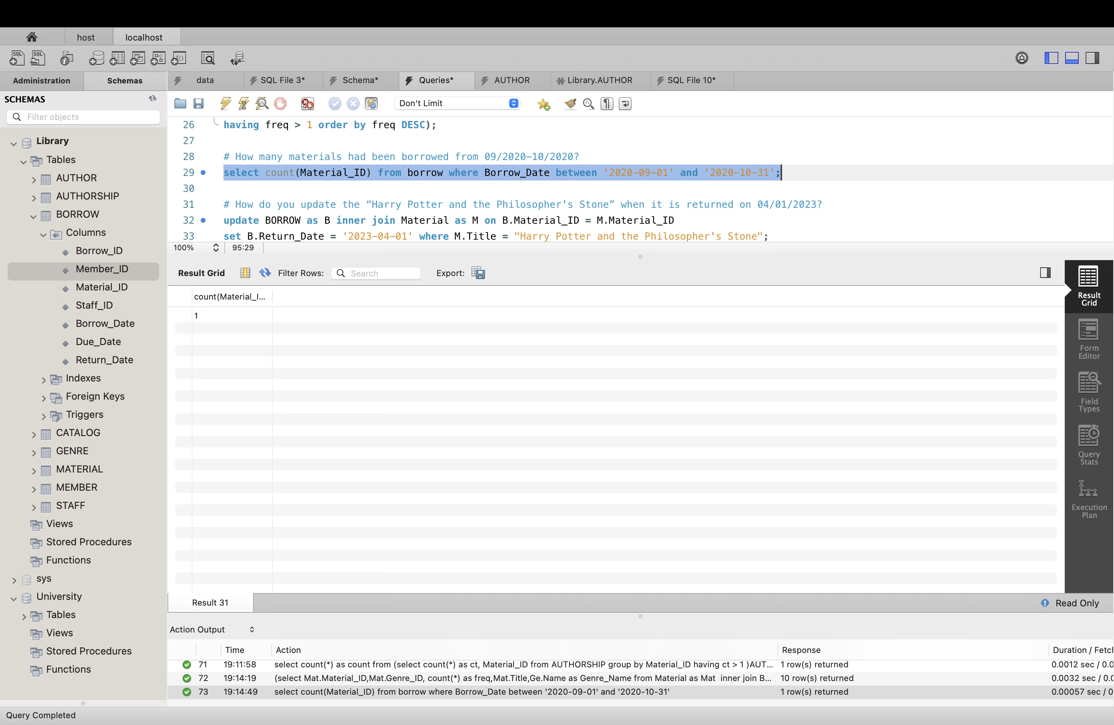

8. How do you update the “Harry Potter and the Philosopher's Stone” when it is returned on

04/01/2023?

update BORROW as BW inner join Material as Mat on BW.Material_ID = Mat.Material_ID set BW.Return_Date = '2023-04-01' where Mat.Title = "Harry Potter and the Philosopher's Stone";

select BW.Return_Date, Mat.Title from BORROW as BW inner join MATERIAL as Mat on

BW.Material_ID = Mat.Material_ID where Mat.Title = "Harry Potter and the Philosopher's Stone";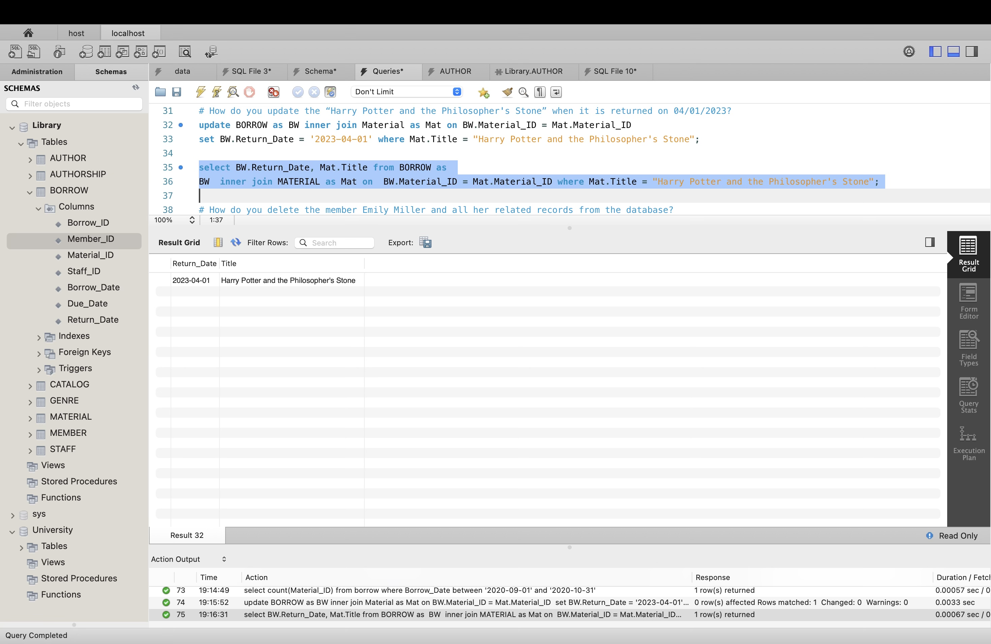

9. How do you delete the member Emily Miller and all her related records from the database?

Delete the borrowing records of "Emily Miller":

DELETE FROM Borrow

WHERE Member_ID = (

SELECT Member_ID

FROM Member

WHERE Name = 'Emily Miller'

);

Delete "Emily Miller" from the Member table:

DELETE FROM Member

WHERE Name = 'Emily Miller';

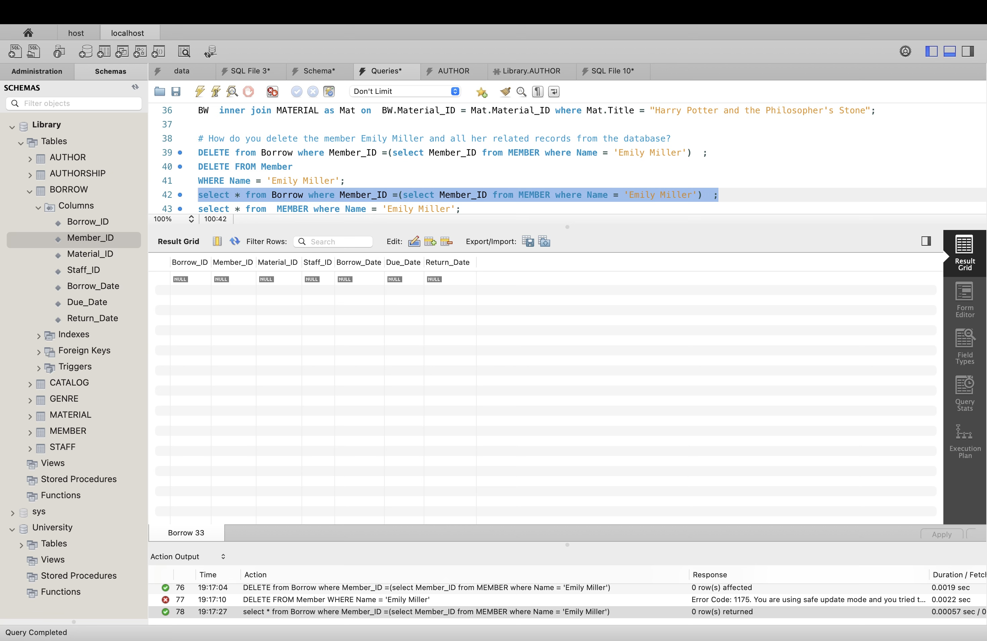

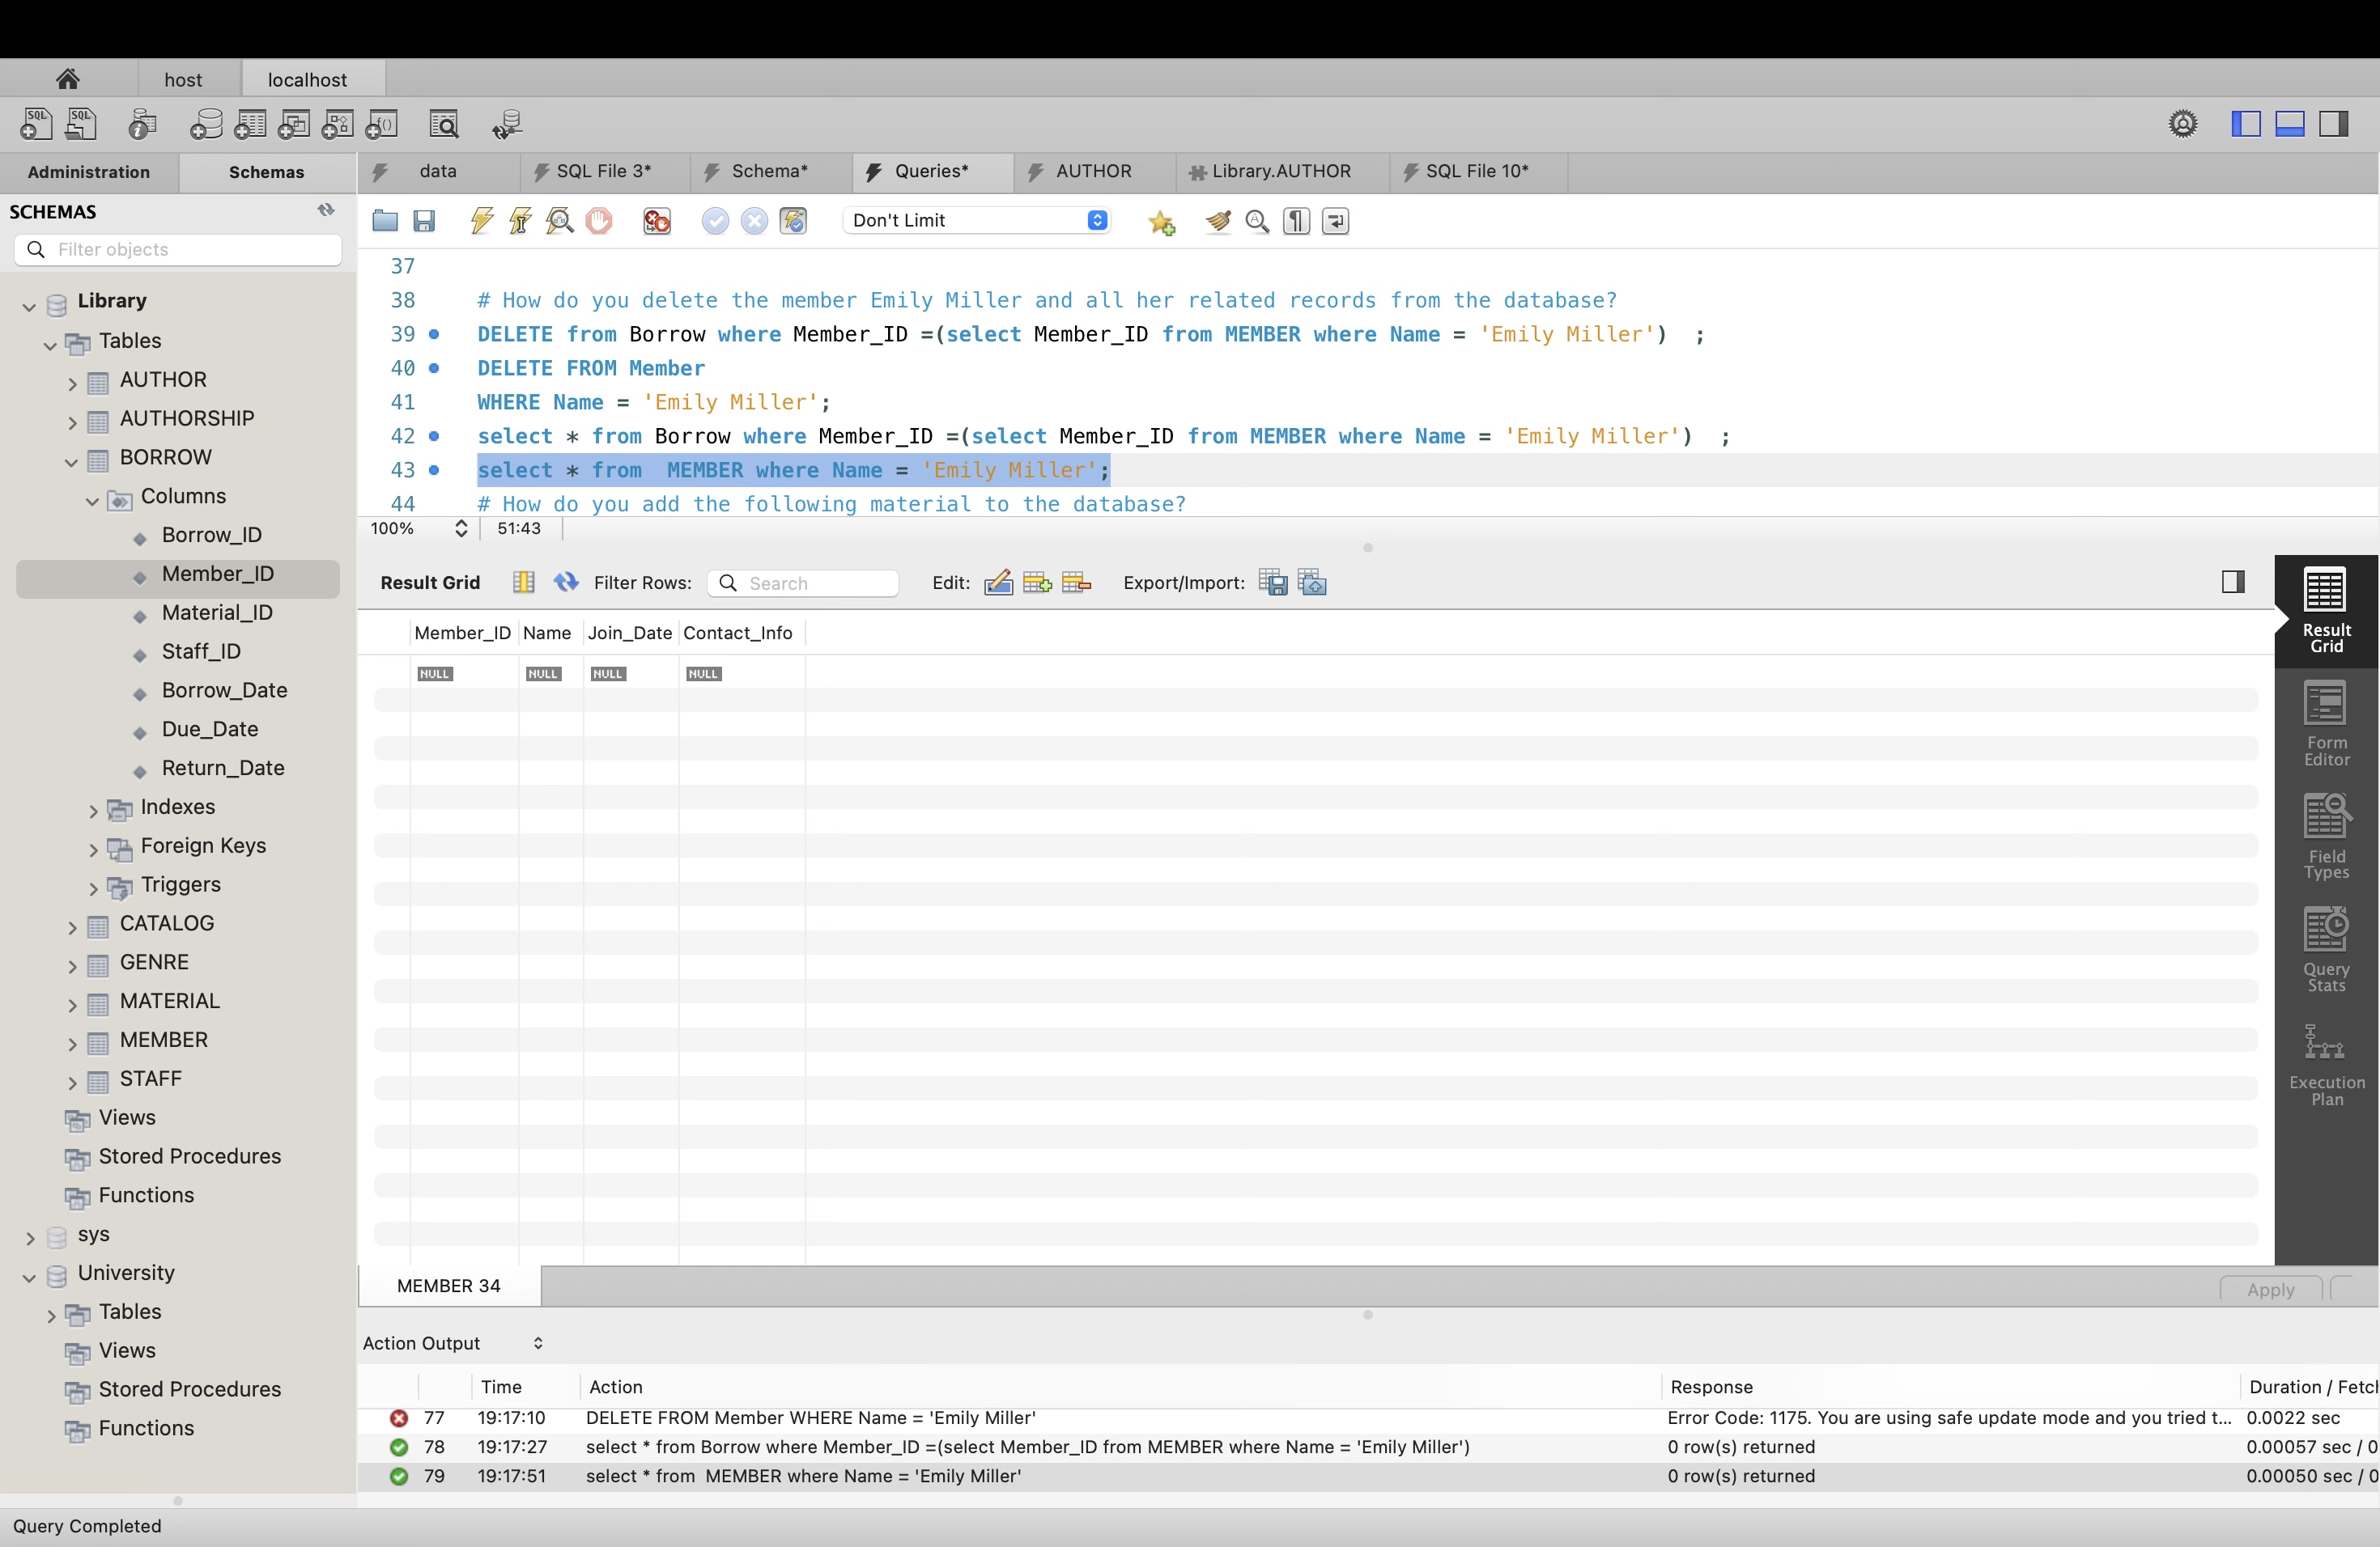

10. How do you add the following material to the database?

Title: New book

Date: 2020-08-01

Catalog: E-Books

Genre: Mystery & Thriller

Author: Lucas Luke

Insert the new material into the Material table:

INSERT INTO Material (Title, Publication_Date, Catalog_ID, Genre_ID)

VALUES (

'New book',

'2020-08-01',

(SELECT Catalog_ID FROM Catalog WHERE Name = 'E-Books'),

(SELECT Genre_ID FROM Genre WHERE Name = 'Mystery & Thriller')

);

Insert the author into the Author table:

INSERT INTO Author (Name)

VALUES ('Lucas Luke');

Insert the authorship into the Authorship table:

INSERT INTO Authorship (Author_ID, Material_ID)

VALUES (

(SELECT Author_ID FROM Author WHERE Name = 'Lucas Luke'),

(SELECT Material_ID FROM Material WHERE Title = 'New book' AND Publication_Date = '2020-08-01')

);

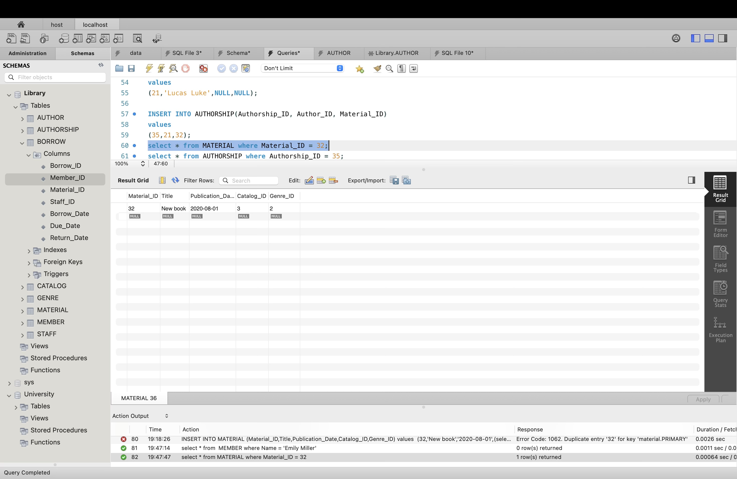

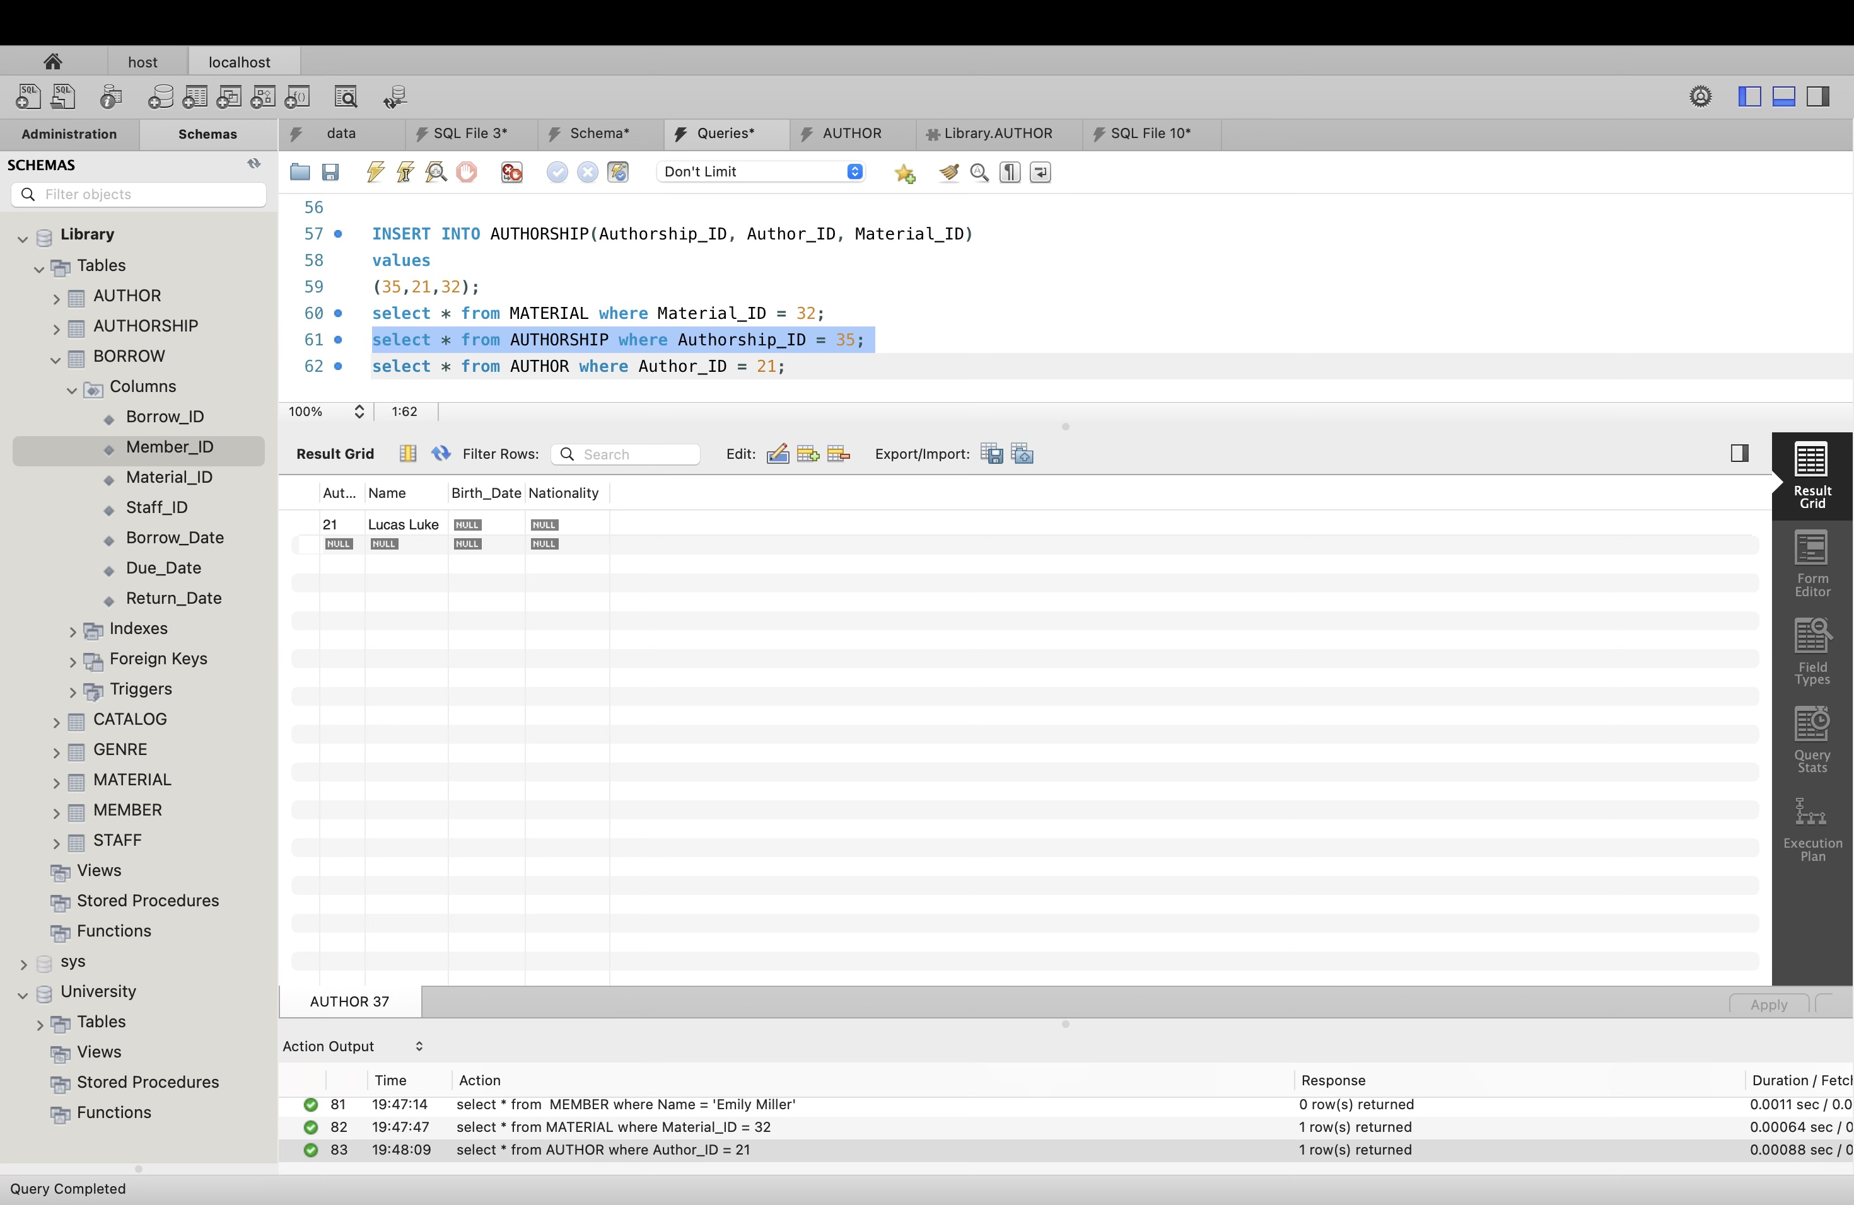

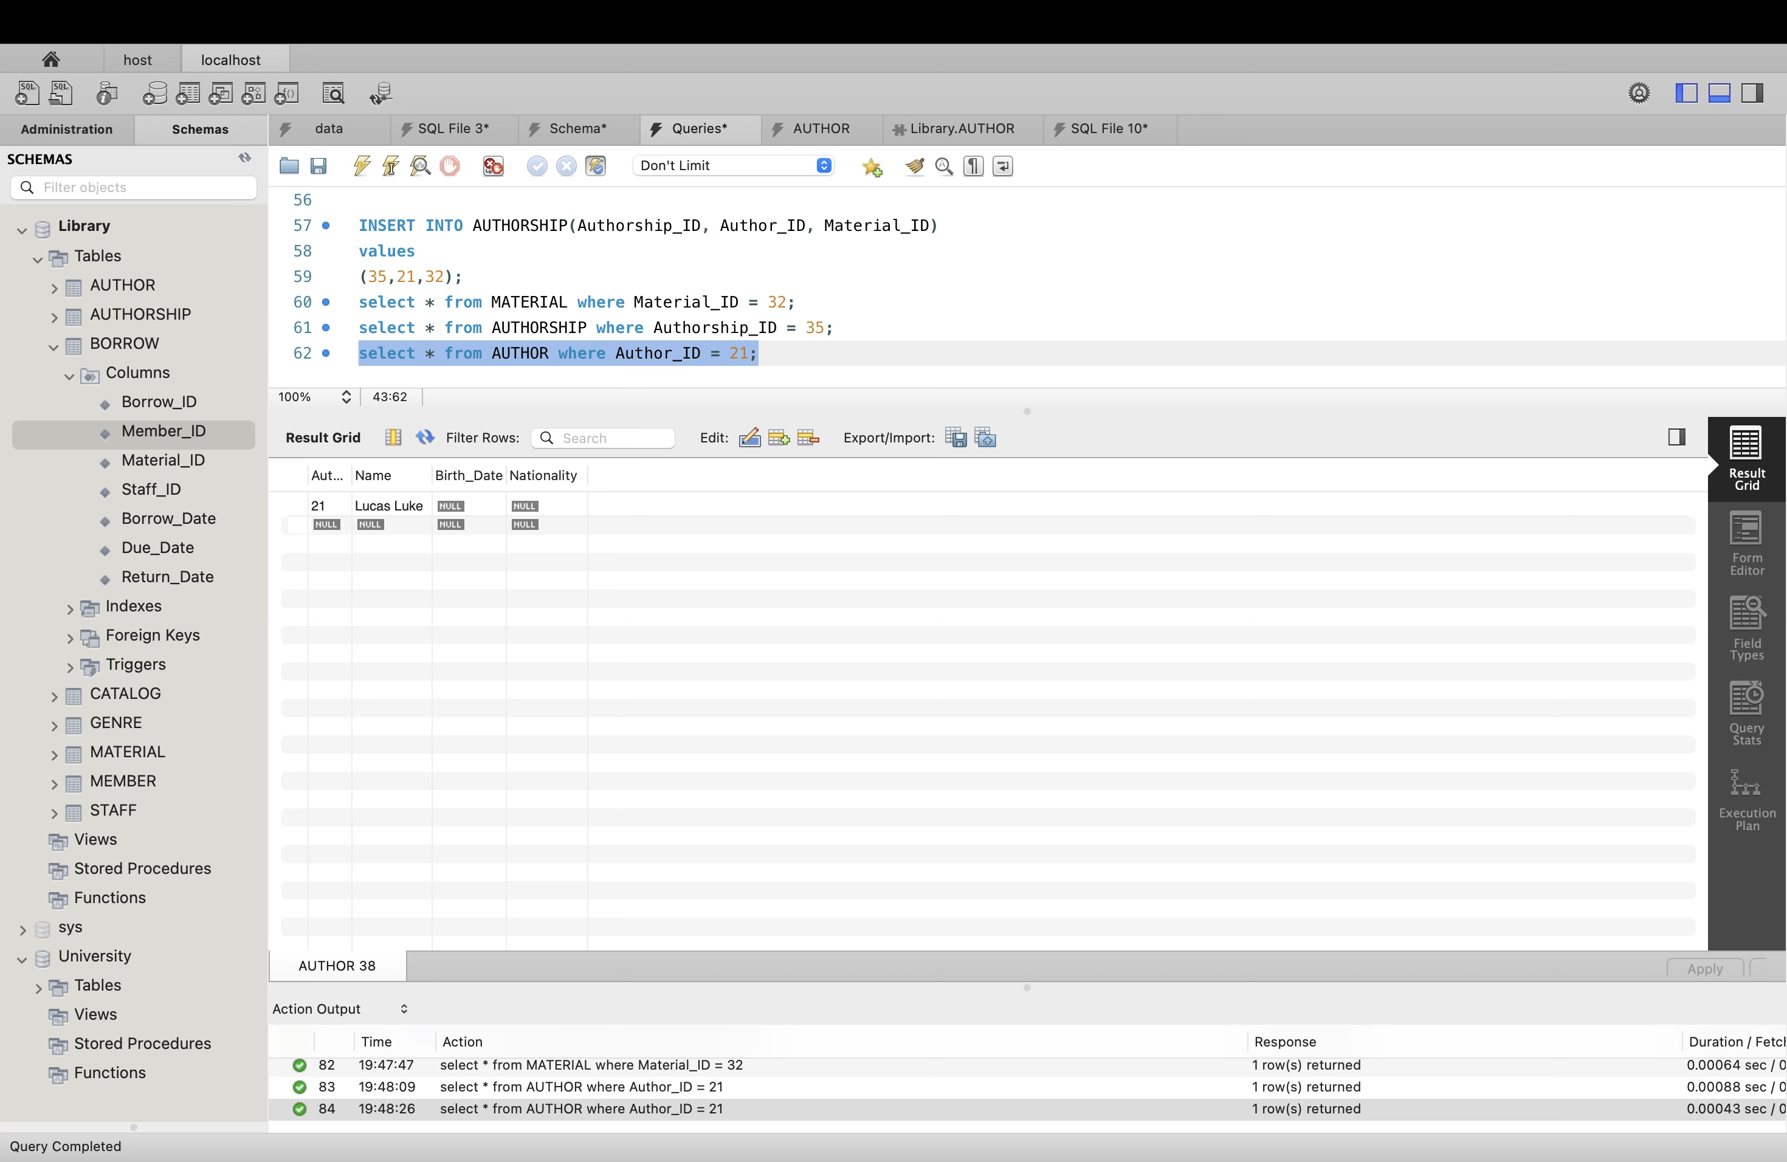

4.2. Design

You are required to explain how to extend the existing database system to incorporate the

following features. While you can provide SQL statements to illustrate your concepts, you don’t

need to execute the statements.

1. Alert staff about overdue materials on a daily basis?

Establish a daily task or employment schedule. Depending on your database system, you could use tools like SQL Server Agent or recurring tasks to accomplish this. To find out which materials are currently being borrowed, have passed their due date, and have not been returned, write a query. Make sure this query executes quickly to prevent performance problems. Select a notification system to notify the staff. This might be utilizing a messaging app, sending emails, or creating in-app notifications. Create a notification message with important information on the late materials. Add information like the names of the borrowers, the material titles, and the due dates. Indicate which employees or job responsibilities should receive the alerts. This makes sure that the appropriate people are informed when things are past due.

2. Automatically deactivate the membership based on the member’s overdue occurrence (>=

three times). And reactivate the membership once the member pays the overdue fee.

Establish a system for recording the instances in which a member has late materials. This could involve running a database query to locate records where the material has not been returned or the due date has gone, then linking those records to the member. Establish a rule that, upon the occurrence of three past-due instances, for example, automatically deactivates a member's membership status. In the database, update the membership status appropriately. Notify the member about the deactivation of their membership, if desired. Email, in-app notifications, or any other desired form of contact can be used for this. Establish a mechanism to verify when a member settles the past-due amount. This could entail manual confirmation by library staff or integration of a payment gateway. By scheduling queries on daily basis, we can track the overdue occurrences and deactive membership.

ADDITIONAL RESOURCES:

More resources are needed when developing and implementing a library management system. To improve the development process, an draw.IO diagramming tool could have a range of resources and instruments. To make sure that the Entity-Relationship Diagram (ERD) follows to accepted practices and efficiently communicates information, guidelines or references on ERD notation could be utilized on draw.io. The project started with a thorough requirements study, which produced a well-organized and defined system design. The draw.io-created Entity-Relationship Diagram (ERD) showed entities, properties, and relationships in a visual representation of the database structure.

CONCULSION:

A Library Management System (LMS) is developed and implemented through a process that combines rigorous planning, design considerations, and resource usage. A comprehension of the system's architecture is aided by the definition and identification of various entities, including Material, Catalog, Genre, Borrow, Author, Member, and Staff, as well as the connections between them. Because of the meticulous implementation of the Borrow entity and associated procedures, borrowing and returning materials was made easy. The purpose of the Member and Staff entities was to effectively manage staff positions and user data. The system has an automatic procedure for managing membership status; it deactivates memberships for past-due incidents and reactivates them if past-due costs are paid. In order to protect user data and conform with applicable rules, security standards and guidelines are taken into consideration during the system design process.